
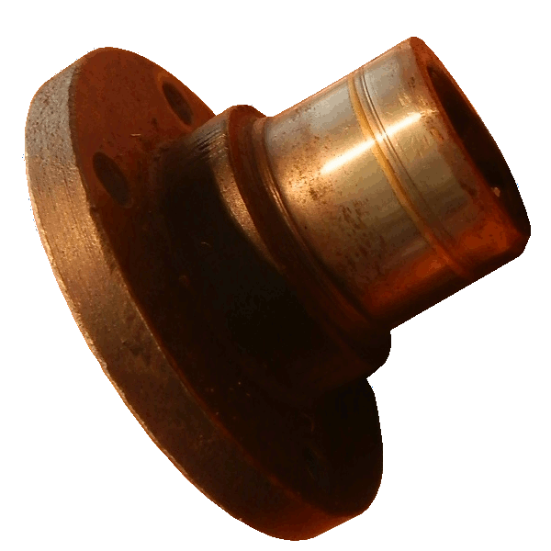
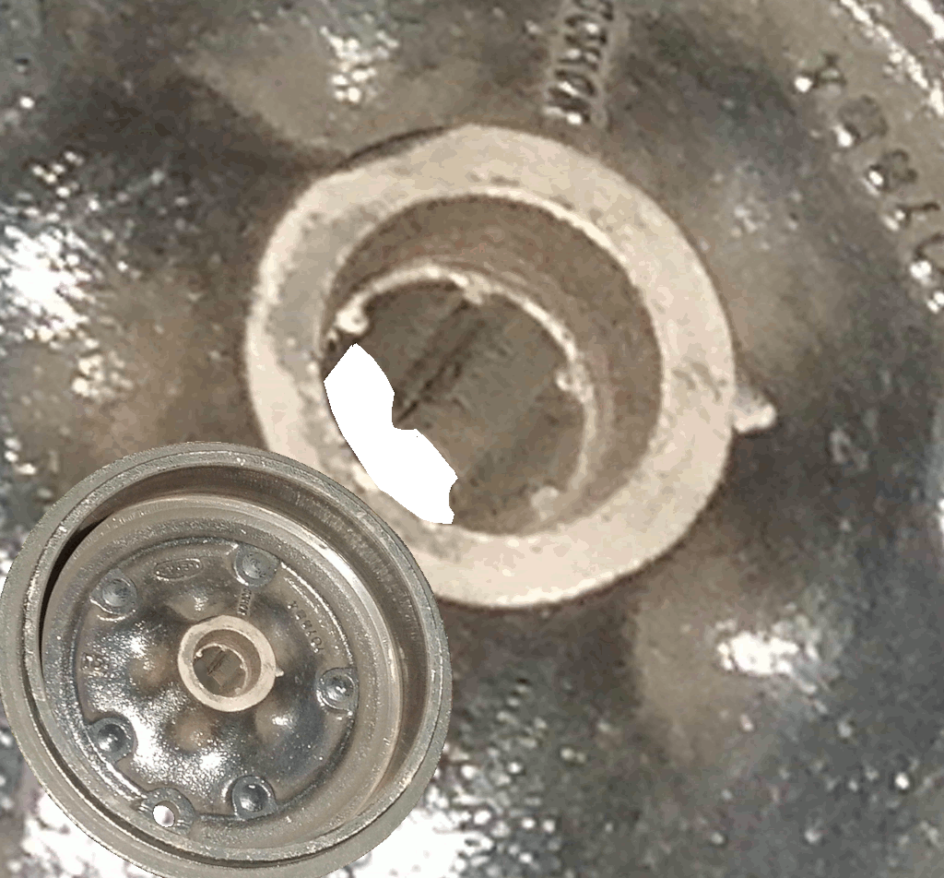
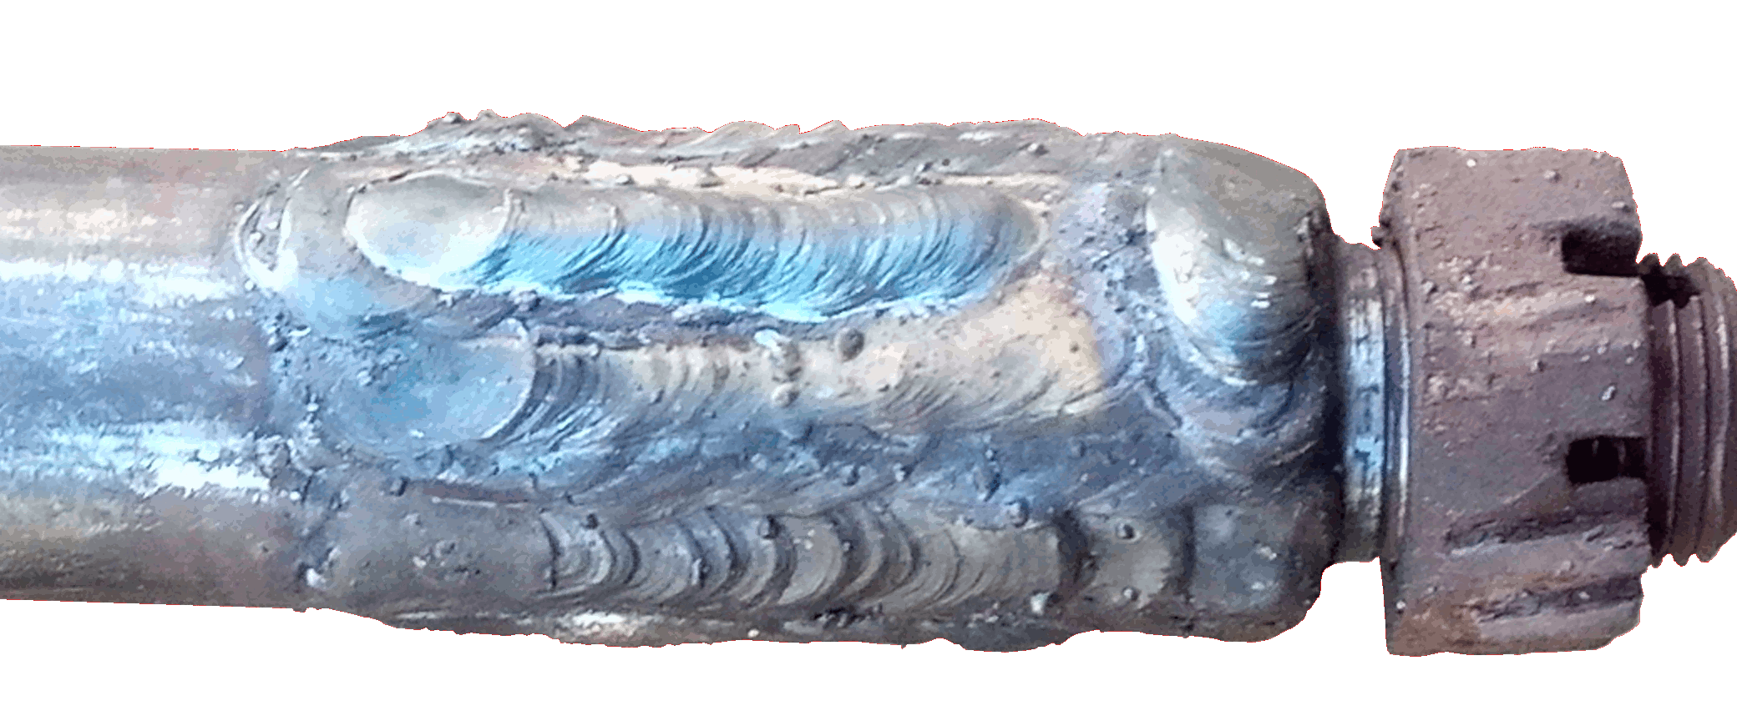
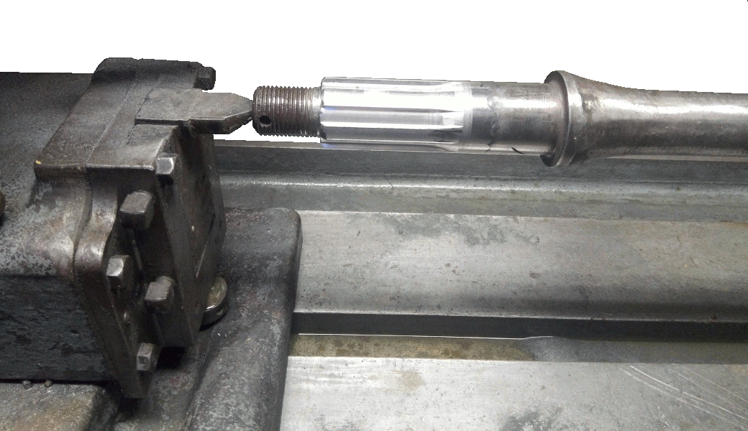
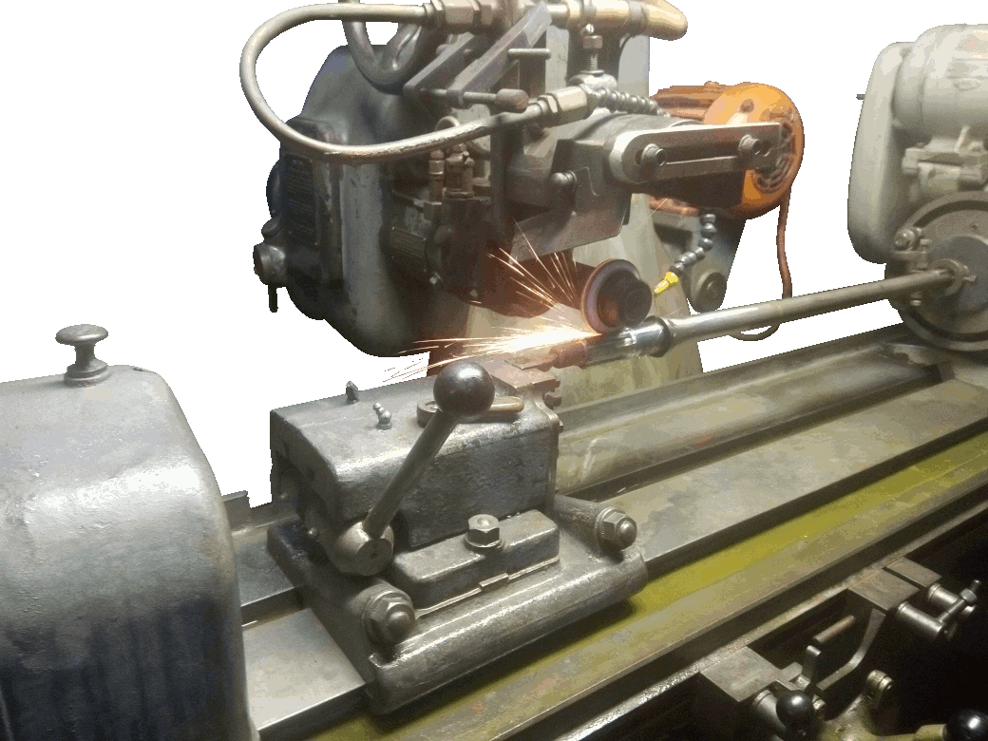
xle repair This story of discovery begins with my not removing the flange and renewing the oil seal at the right time. Because I thought I could get away with it, I didn't do it straight away, which meant I had to do it later. It turned out that the oil seal was defective, and that meant the expensive axle oil was sprayed in a vertical circle all over the back end of the car. But the really serious problem was that the wheel bearings are lubricated from the axle oil, and when it had finished lubricating the road, there was none left for the wheel bearings. We were lucky that only one failed, and that it failed before the axle and differential.
So I had to withdraw the flange and replace the oil seal after all. The nut is tightened to 140 ft.lb: that is a lot of torque, in fact it is at the very upper limit on my torque spanner. I used a couple of feet of 2" angle iron, drilled to fit two of the flange bolts, and braced it against the ground while I undid the flange nut. It turned out that the flange's sealing surface was badly worn by the rubber oil seal (#24) which had hardened during the long layoff, and after rifling through my supplier's entire stock of used parts, I couldn't find one which was not worn, which leads me to think it is likely to be a universal problem. So I cleaned out the debris from the failed bearing, sleeved the flange with a Speedisleeve, renewed the oil seal, and there has been no more problem. From that source, anyway.
Dismantling to replace the wheelbearing was routine: take out the splitpin, slacken the nut, jack up the car, take off the wheel, take off the nut, lever off the brakedrum, undo the four bolts holding the backplate, and remove the brake assembly complete, without undoing the hydraulic lines. Prise off the bearing carrier with the oilseal, which allows the split, tapered oilseal collar to be removed. And that was as far as I could get on my own - I couldn't press the old bearing off.
I sourced a new bearing, and took it all up to the local garage, who, for a trifling sum, pressed the old bearing off, and pressed the new bearing on.
Now to prevent a stress point, a substantial radius is machined into the axle behind the bearing. To allow the bearing to to bed securely against the shoulder, a small spacer is placed behind the bearing to match this radius - that would be part number 32 in the exploded diagram in the owners manual. The reason they charged so little was because they saved time by omitting this spacer, AND I DIDN'T NOTICE, and although I should have noticed, I blame it on the garage, and I discussed with them, and it will be a surprise to both of us if I ever go back there again.
Anyway, I reassembled it in reverse order, and tightened the nut, as I thought. Now the brakedrum has a tapered locator which matches the taper on the split collar. Tightening the nut is supposed to pull the brakedrum firmly onto this collar, and compress the split, so that the collar grips tightly onto the halfshaft while at the same time securely clamping the bearing to the shoulder on the axle. The nut, I learn, is supposed to be tightened up to 140 ft.lb, although in 60 years of taking brake hubs on and off this has never been a problem to me - of course I've never tried it before without the important spacer. From one of the bulletin boards, I learnt that if it's not tightened sufficiently, then the splined hub can move on the half-shaft splines, ruining both the hub and the shaft. Another thread described how a wheel was lost from this problem. The consequence of having omitted the spacer was that although I tightened the nut as I had always done I was in fact tightening the hub onto the end of the splines instead of tightening against the shoulder on the axle. The splined hub did indeed move on the splined halfshaft, and both were indeed ruined. I don't think I was about to lose a wheel, but I think you can see that there isn't a lot of spline left and in another couple of hundred miles they would all have been hammered out and I would have had no drive.
I sourced two new drums in UK, although due to corona-virus, my plans for getting them here didn't work. But in due course, one of them did arrive.
The half shaft was another story. The outer splines were wrecked. I had the option of converting a halfshaft from a Wolseley 4/44. It was about 15mm too long, and would have to be cut down and the inboard splines extended by about the same length. There was another thread on the mg-cars.org bulletin board which suggested that the splines could be extended using a handheld angle grinder. Steve, a qualified fitter who I'm sure would have recommended a hand-held angle grinder had he thought it possible, LOLd. A number of different authors on the same thread cautioned against that solution. I didn't choose that option, and the Wolseley shaft will still be available should I need it in the future.
The option I took, following a conversation with Steve was to repair the halfshaft I had. The splines were built up by welding then turned and ground to the correct diameter and the new splines cut using Geoff's spline grinder. I had never seen one of these and in fact had no idea such a thing existed, and I begged to be allowed to watch the process in defiance of all OH&S rules. Now I don't say it would be impossible to do by hand (but Steve does!), and given the Peter’s undoubted skill and credibility, I'm sure he could make it work. But to see these two fitters meticulously measuring the depth and width of the splines and dressing the grinding wheel to the exact shape to give a light interference fit with the internal splines on the drum convinced me that for me to have done the job by hand I would need to have hands calibrated to about 1/10thou - much better than my geriatric hands can manage.
Assembly was straightforward, with a new bearing (again) and remembering the spacer this time, and torquing it down to the recommended 140 ft.lb.
Anyway, we're back on the road again. But annoyingly, the new right-hand hub has UNF threads, while the left-hand one still has BSF. When I'm reunited with the second hub I will replace the left-hand hub, so that at least they're the same. But it will wreck my chances of ever winning concourse, because I'm sure the judges will look at these threads, and compare them with the chassis number, and realise they're wrong for the car.

